Read and delete! Trainers: If you edit this file, please change the file name to show
the region and date [YYYYMMDD]: IFLA_IAP_Topic2_RoleOfLibraries_Activity2.5_Worksheet_Region_YYYYMMDD
IFLA INTERNATIONAL ADVOCACY PROGRAMME
LIBRARIES, DEVELOPMENT, AND THE UN 2030 AGENDA
TOPIC 2: THE ROLE OF LIBRARIES IN THE UN 2030 AGENDA
ACTIVITY 2.5: YOUR AWARENESS CAMPAIGN

INSTRUCTIONS
When you return home, you will need to embark on a programme to raise awareness about the UN 2030 Agenda, the Sustainable Development Goals and the development planning processes in your country or region.

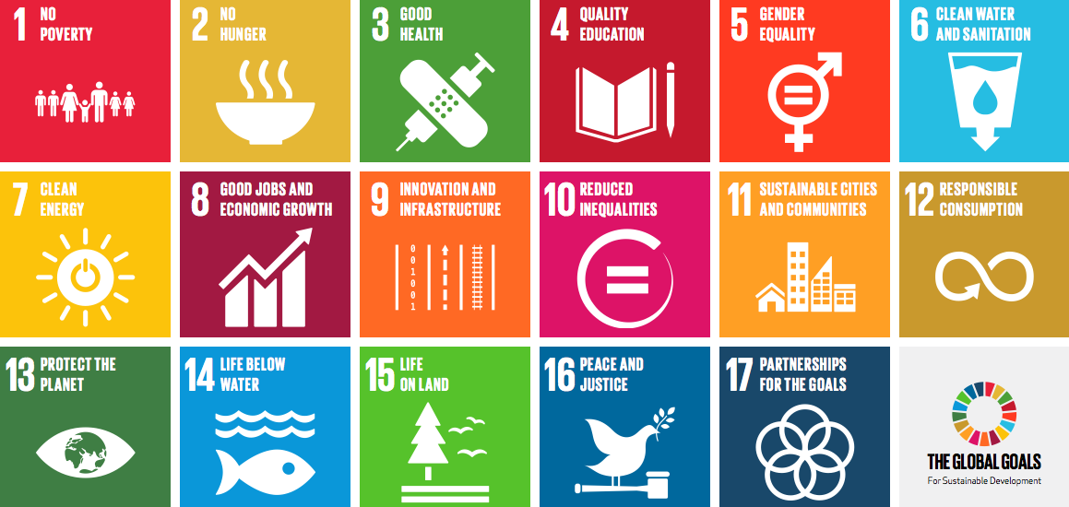

How will you do this?
Think about the following questions and come up with some ideas about what you could do:
  - What are the objectives of your awareness campaign?
  - Who will help you organise the campaign?
  - Who will your target audiences be?
  - Who would you like to partner with?
  - What type of activities could you undertake?
  - What are the timelines for your campaign?
  - What communication strategies will you use?

Our awareness campaign for the UN 2030 Agenda
- What are the objectives of your awareness campaign?

- Who will help you organise the campaign?

- Who will your target audiences be?

- Who would you like to partner with?

- What type of activities could you undertake?

- What are the timelines for your campaign?

- What communication strategies will you use?

- Other ideas

