IFLA Management and Marketing Standing Committee

M&M SC Mid-Winter Meeting, February 22-24, 2017
Vilnius, Lithuania
Venue: National Library of Lithuania

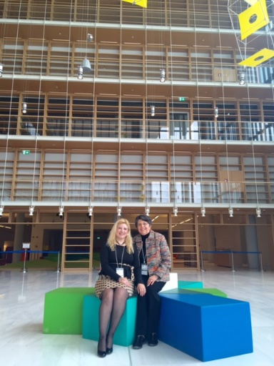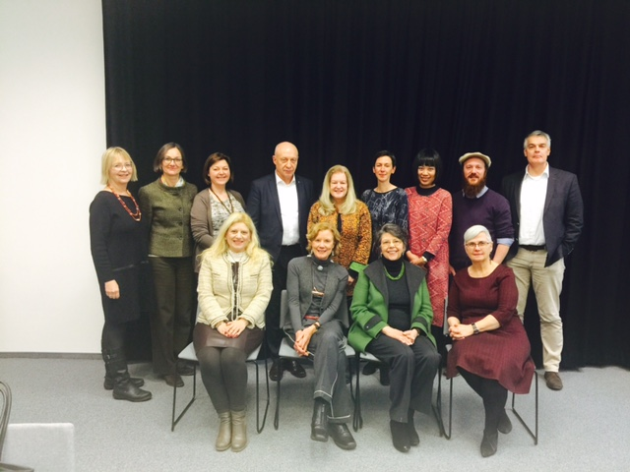

DRAFT MINUTES

Attending: Nancy E. Gwinn, Chair; Antonia Arahova, Secretary; Cindy Hill; Information Officer; Perry Moree; Silvère Mercier; Hella Klauser; Leslie Weir; Wiebke Dahlhoff; Ruth Ornholt; Renaldas Gudauskas; Christie Koontz; Nie Ha; Ludmila Zaytseva

The meetings were held in the beautiful new National Library of Lithuania. Host Renaldas Gudauskas arranged for a tour of the impressive facility, gave us lunches in a special room in the staff cafeteria, and concluded our meeting with a dinner at a lovely restaurant. Thank you Renaldas!

Approval of Agenda and Minutes of SC Meetings in Cape Town
The meeting started with warm thanks to M&M SC Member, Renaldas Gudauskas, and his colleagues for the very professional preparation and hosting of the meeting. Chair Nancy Gwinn asked for the approval of the Minutes of M&M SC Meetings in Columbus, Ohio, August 2016 and the approval of the agenda.
Agenda and minutes approved.

IFLA BibLibre Marketing Award 2017
Silvère Mercier, Chair in the Jury of the IFLA BibLibre International Marketing Award, reported the decision of the present Jury members: Antonia Arahova, Ruth Ornholt, Weibke Dalhoff, Leslie Weir, Nie Ha, Ludmila Zaytseva and Christie Koontz. The Jury had hard work as they received 65 applications. from 11 countries, in 5 languages from all over the world! The winners for 2017 were:

[2017 Winner!] READay - Library of University of Science and Technology Beijing - China
[2nd place] Open Data Application Development Contest 2016 @ Shanghai Library - China
[3rd place] Little Paradise Human Library - Wuhan University Library - China

Among the 65 applicants, the jury selected the 10 projects that were most inspirational. The following projects did not make it to the podium but deserved to be highlighted:

[Australia] Spotlight on Libraries x 3 - Sunshine Coast Libraries
[Canada] Open Access Week Campaign -UBC Library
[China] Utopia for Children' s Reading – Liaoning Provincial Library
[China] 2016 Shanghai Jiao Tong University Library Orientation: Micro Video - Shangai Jiaotong University Library
[China] WE READING (The Digital Reading Project of the Shanghai Library) - Shanghai Library
[Russian Federation] See / Read / Listen - Boris Yeltsin Presidential Library
[Russian Federation] Country reading rooms invite friends- Khakas Republican Children's Library

A press release will be circulated the next days. A website publication and webmap will be formed. The winners will be notified and an email letter sent to the ones who didn't win. The committee decided that neither the first nor the second-place winner would be allowed to apply for the following five years. Many thanks to our sponsor: BibLibre, Open Source software and services for libraries.

WLIC Draft program Wroclaw, Poland
Save the dates:

- 19/8 Saturday, Management and Marketing SC I 8.00-10.00.
- 20/8 Sunday, Management and Marketing, (Libraries and Marketing) 13.45-15.45 Room 2
- 23/8 Wednesday, Management and Marketing SC II. International Marketing Award 11.45-12.45 Room 2
- 23/8 Wednesday, Library Buildings and Equipment with Management and Marketing International Marketing Award "Bridging: Building: Telling and Selling the Space Story " 13.45-15.45 Room 1
- 24/8 Thursday, Management and Marketing SC II. 13.30-16.00

The time for the first SC meeting has been reduced from 2 1/2 hrs to 2hrs and the time for the second meeting increased by half an hour. Election of officers will take place at the first meeting.

The SC dinner is planned for Monday evening of August 21.

Satellite Meeting 2017: location and program
Ruth reported that the satellite meeting will take place in Bergen, Norway. It is a joint conference between Public Libraries Sections and Management and Marketing Section. Topic: Managing Change: Library Transitions – moving into the future. Best practices from around the world
Date: 16 – 17 August 2017. Organizers: Hordaland County Library and Bergen Public Library
Location: Bergen Public Library, Bergen (Norway)

There has been a call for papers with 19 proposals received. In addition, members of the two organizing committees, who are coming to Bergen, are invited to give Key Notes or Pecha Kucha-presentations. Libraries from Norway will also be invited to present examples of Best Practice.

The program will mostly have parallel sessions for public and academic libraries.

The conference has received funding from the Norwegian National Library and about 12 sponsors. The conference-fee will therefore be about 80 Euros and there is a possibility to sponsor some of the speakers with accommodation and conference-fee.
All information about the conference is to be found here: http://www.managingchange2017.org/

Open Session, Wroclaw 2017
Diane Koen, Chair of the Library Buildings and Equipment Section, organized the call and selection of papers for our Open Session, with input from her committee and Hella Klauser, Pat Wand, and Antonia Arahova, of ours. That promises to be an excellent session as well. Thanks to Diane!

Future programs
IFLA WLIC 2018 will be held in Kuala Lumpur, Malaysia.
We discussed the 2018 conference in Kuala Lumpur but came to no conclusions about programming yet. We should focus on our management side in the Open Session.

Satellite Meeting 2018 in Singapore?
Nancy has had an offer of a venue in Singapore if we wish to have a satellite conference, so we’ll need to decide if we want to do this or relax for a year. NOTE: The SC is “relaxing.”

Elections
We learned that for the 7 vacancies on our committee, there have been 16 nominations, some, of course, from current members seeking their second terms. When the ballot comes out, be sure to vote! We will also have elections for Chair and Secretary. Nancy is willing to stand again for chair. Tonia is standing for Division Chair, and if she is elected [NOTE: She was elected!], then the Secretary slot will be wide open. We would be pleased to receive any other indications of interest in these two positions and will send out a call when we are closer to the August conference.
Eventually, but luckily not until 2019, Silvere Mercier will be forced to leave the committee when his second term is finished. Fortunately, Wiebke Dalhoff has agreed to be the assistant jury chair and learn all about Silvere’s process for organizing the review of award proposals. Thank you Wiebke!

Other business

Nancy reported that she and Antonia will participate in IFLA Global Vision Workshop, which will take place in Athens 3-5 April, 2017 at the new building of The National Library of Greece at Stavros Niarchos Foundation.

Christie reported that the survey for winners of the IFLA Marketing award is completed and constructed. Christie Koontz and Vera McKeown developed the survey. Mila provided winner data from the last 15 years, and Vera is setting up SurveyMonkey to send out the questionnaire to the top three. They realize, based upon Silvere, Antonia and Henar’s work, that many from the past have changed positions and we may not reach them. They are hopeful that they can at least get adequate data from more recent winners. They should have some results to share by the annual meeting.

The Marketing Guidelines are underway. Christie Koontz has reviewed some other IFLA Guidelines that are posted (no published) for format and outline. She has started this project and will work with Antonia on that for additions and review. These will be available for any one on our website, hopefully by late 2017.

The Communications plan is currently being worked on by Vera, Christie and Cindy Hill and it requires more input.
SC members are invited to think of writing articles for IFLA Journal.

Tonia will coordinate the next Zoom call among SC members after the IFLA Global Vision Meeting in Athens, 3-5 of March 2017. The date will be announced early May. A main call is scheduled in June before WLIC.

The meeting was adjourned at 18:50h.

