**Multimedia, Creativity and New Ways of Learning – Välkky, The New Mobile Library in Espoo, Finland.**

Välkky is a Mobile Library in Espoo, Finland, a city in the municipality area of Helsinki. The bus includes, among books and other lending material, interactive media technology such as ipads, a video projector and a screen and a big touch screen table. The space can easily be changed according to use.

The mobile library Välkky, which started operating in the spring of 2013, is part of the so called Outreach services of Espoo library. These services are two mobile libraries, the other bus Helmi being a more traditional mobile library operating mostly in the afternoons and evenings, the home library , one small hospital library and the Espoo library logistics section.

In the mornings the Mobile library Välkky visits schools and daycare centers as a modern children´s library. In the afternoons and evenings Välkky can be changed to a bus for different groups of children and adults, functioning as a writer´s bus, a movie theater, a multimedia workshop, a meeting place for a book club or a handicraft group.

**The story of the mobile library Välkky**

The task of mobile libraries is to promote equality by bringing library services near the users. Mobile libraries are flexible and able to take into account the wishes of the customers. They are perceived as intimate and safe places where you are certain to get personal service. Mobile libraries also function as a kind of display window for library services in general.

The decision of the Espoo library in 2011 to invest in a new kind of mobile library was founded in the principles above. The principles haven´t changed with time, but their content has. The modern mobile library works from a social perspective. It sees information as something people share with each other

To be able to offer library services near the users, that is, mobile library services of today, first you need a space that can be changed according to different needs and user groups. Secondly, one needs a new kind of technology. Thirdly, the planning of these new library services should be done together with the users, the future customers.

**The space and the users**

The mobile library Välkky was realized as a collaboration between the Espoo library and the departments of Media and Spatial design at Aalto University. The concept for the bus was developed through workshops that the Aalto University students arranged together with future users, for example schools and day-care centers in Espoo.

*The interior of Välkky is an ongoing project. Celebrating the Moomin author Tove Jansson, a school class helped us decorate the walls of the bus. The pupils chose quotations to their liking from the original Moomin books and the result, with the help of a vinyl cutter, is inspiring.*

he space in Välkky has been made as convertible as possible. The different kinds of shelves, some for children´s picture books, some for tablets, are all modules, except for the ones high up which can be turned towards the walls when not in use. Shelves can be replaced by a sofa, made especially for the bus, sitting cushions, folding chairs, a touch screen table or simply left out for providing space for fairytale yoga or a big audience.

The “ stage” in the back of the bus is used in multiple ways, as a place for an indoor picnic by a Spanish speaking parent and child group, as a platform for an audience of children listening to an author reading to them from her book. It is also used as a stage for music performances and puppet theatre performances. Most fun has been had with our stage when we have been able to inspire the users to come and perform on it.

**The technology and the users**

There is one stationary computer for the library staff and two, removable, self-service machines in Välkky, especially made for the bus. Colorful pictures on a big screen give instructions how to use the lending or returning functions of the automat.

The staff is equipped with ipads for online search. The bus has a box for charging 10 customer tablets at a time and is able to provide a school class attending a workshop in the bus with up to 20 ipads. There is also a Mac computer for the use of the staff, a video projector and a screen, a printer, a Playstation and a large touch screen table.

The ipads in Välkky are used for searching information together with the customers or simply for teaching different customer groups the use of tablets and the internet. They are also used in various workshops, for example making music, animations or posters, or simply for playing games on them.

**Learning is fun - the mathematics bus**

This spring the mobile library initiated a collaboration with a publishing company for e-learning media and a school. The publishing company gave the mobile library access to their e-media for children learning mathematics and the library organized a “mathematics bus” where we tried out new ways of doing mathematics together with schoolclasses. Our concept was to combine learning and playing, the mental and the psysical. For the first graders Välkky was a maths and fun gymnastics bus, for the third graders Välkky functioned as a maths and animation bus. The animations were filmed by the children running around outside the bus.

The program in the mathematics bus was a success, even the children who usually have trouble concentrating, managed to concentrate on the tasks in the inspiring, limited and safe space that Välkky offers. The mobile library continues developing the concept of the learning bus. Here one of the aims is to combine the use of technology with physical activities such as drama or playful exercises .

**You are welcome to use your phones in the library! – bringing life into the book shelves through NFC and QR-techniques**

Another ongoing project is using NFC (near field technology), a mobile phone technology , where the aim is to open up the children´s collection in the bus to our users and at the same time involve our users in the process.

We are doing a series of workshops with participants of different ages producing short videos (max 30 s long) mostly with the participants filming each other telling and showing in various ways why they liked a certain book, movie, or game. We have a drama instructor/facilitator in our project group and one of his tasks is to try to get the children and young people to forget about how they think you should talk about books (especially what they think teachers and librarians are expecting from them).

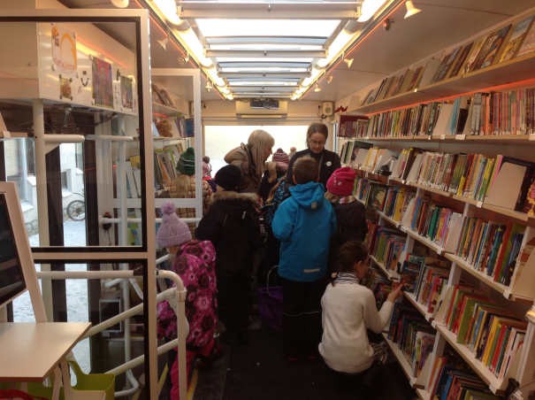

*In the near future: when Olli, 10 years old and not an eager reader, is looking for that compulsory book the teacher has said he has to find, he can bring out his phone and read the NFC stickers on the books. On the screen of his phone a face of another boy might pop up, telling him with a big smile why he, to his big surprise, actually had enjoyed the story.*



*The videos turned out great, but there is something to be said for the concept of the participants filming each other. Not so intimidating, more fun and play.*

The main purpose of the video project this autumn in the bus is to invite our library users to produce the material with us. We still couldn´t resist making a head start when a school class suddenly announced that they had ten eager readers who wanted to recommend books for younger children. This time we did it with film students quite professionally filming and editing the videos, teaching us a lot in the process. Next time we are on our own, we and the participants.

For the project we have acquired smart phones to be used in the bus by customers who come into the bus without one. Another way to show the videos will be through different sized tablets working as code readers. By showing a book to a tablet in a holder on the shelf you are presented with additional information , for example recommendations for other similar books ( one category probably being “fun, not too long”).

**The new library: the staff and the community**

The new space and the technology are only the beginning. What counts is how they are being used and for that you need people, staff with the adequate skills for the job.

When you have a library space intended for different kinds of events you need people who can function as cultural producers, make contacts outside the library and handle the creative chaos that follows.

There are still projects within libraries or presented by potential outside collaborators to the library where the focus is on the technology. There is a budget, but the money is for the IT-technology. However, what you need most are people who know how to use the technology and who are good at passing on their skills and knowledge to the users.

The permanent staff of the mobile library in Espoo, with two buses serving a large community, consists of six persons, many of whom have worked for the library for a long time in a closely knitted team. This team has experienced a turmoil of change for over a year now. We are learning by doing, by trying out things, together with our community, often for the first time.

There is a strong commitment to the needs of the users among the staff. The staff is also used to being in close contact with the users from before, they know how to do small talk (here possibly differing from the majority of the Finnish people, known for their taciturn disposition). The staff of mobile libraries has also always had to be flexible by necessity, often having had to come up with practical solutions to problems caused by too few drivers, too much snow on the roads, the sudden lack of network in a bus full of customers.

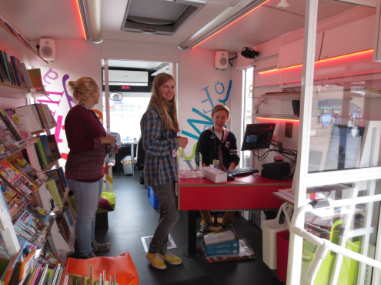

*Co-ownership of the library. Visiting an event for young people, the young people arranging the event outside the bus decide to take over the information desk for their own needs. Needless to say they also handle the occasional lending situations and information searches in an excellent way.*

In Espoo cooperation between the libraries is encouraged. That means that the mobile library gets help for example from the young people´s librarians or the children´s librarians when we organize events and projects. The Finnish state also offers the possibility to seek financial support for innovative projects in libraries.

The mobile library also takes on an increasing number of different kinds of trainees, some of them needing a lot of support and others bringing new knowledge and valuable skills to the team from day one. The addition of new people, from different cultures and educational backgrounds, to an earlier fairly homogenous working team facing a lot of new expectations, is not a bad thing. The inevitable “cultural clashes” that follow have to be resolved. The working community has to learn to communicate, also about the more difficult issues.

When there are big changes going on in a workplace, it is important that there also exists an open dialogue, a dialogue where you learn to laugh at the failures and rejoice in the successes. The dialogue extends to the customers, the library users, some of them praising the new concept and wanting enthusiastically to cooperate with the staff, some of them in various stages of anger, needing reassurances that the end of the book isn´t near.

The staff of the mobile library has been used to almost exclusive praise of the service through the years. But change generates both praise and criticism ( and the saying If everybody likes you, you are doing it wrong, might only help a little). When the first negative feedback was posted on the mobile library´s facebook page, one of the drivers answered the customer without hesitation. The customer wrote a cheerful reply and everything was well. This dialogue was there in the open, for all to see.

**A Mobile library for everyone**

There are impressive libraries in the center of cities around the world, libraries which have been modernized with designer furniture and new technology. The city of Espoo has invested a great deal in libraries that are situated outside the tourist routes, for example Entresse library, situated in an area with a high unemployment rate and the Mobile library, with the main target groups being children, families, seniors and people without means to travel to the big libraries in the center.

Investing in quality libraries in the suburbs is, among other things, investing in a safe and stable society. A society that is made more stable with informed and active citizens who are encouraged to feel that they belong.

The idea of Välkky is to be able to offer the services of a modern library to its users. That means, among other things, modern technology. The bigger part being learning, communicating, playing, the staff finding out ways to use the mobile library together with the users.

In Finland the libraries cooperate regularly with the teachers in the schools. The schoolchildren in Espoo visit the library for reading suggestions and lessons in information retrieval. They are also participating in various media workshops at the libraries. There are several advantages to the school classes regularly visiting the local library. The children learn that the library is also their place and they experience an “adult” world outside the school that also embraces reading and culture.

The mobile library´s collaboration with schools and day care centers is more and more aiming to help the children to find their creativity in many fields. The focus in the learning bus is very much on interaction and communication whether the subject is mathematics, arts, literature or natural science.

The Love & friendship bus, lead by a sexual adviser and a youth librarian, tours secondary schools with a program consisting of recommendations of good reading and group discussions derived from fictive examples about most things that concern teenagers. The No bullying -bus with good reading ( most importantly, stories about heroes and heroines surviving a cruel fate) and a program about internet etiquette for children tours schools with a youth leader and a librarian.

Välkky also visits community feasts, sport events, film festivals, shopping centers and so on. Sometimes the bus functions as a lending library with a lot of material (including skates in the winter)and ipads for internet search. Sometimes it’s a movie theater, a fairytale yoga bus, a place where you can meet an expert on gardening or a popular author.

The Mobile library is able to achieve what the stationary libraries cannot do, going out of the library building, reaching people who don´t know about the library or who don´t feel that libraries are for them, and at the same time bringing the library with it.

What some of us at the mobile library like best is combining unexpected elements for making something new. The maths bus is one example, with the combination of playful gymnastics and maths. Fairytale yoga, gymnastic exercises in Spanish for families with small children, our Karaoke & Book bus and our Mind travel – bus, with seniors recalling the past together with the staff in the modern media bus, have resulted in many AHA moments.

The media- and event bus Välkky is a unique concept. Välkky, being one of a kind, gives us a lot of freedom trying out things and developing the concept together with our community. The Espoo mobile library wants to be an activator in the community, creating knowledge and culture together with the community members, our customers.

The mobile library Välkky: height: 3400mm, length: 12m, Diesel engine, Chassis: Volvo, Body: Kiitokori. Shelfmodule system: design Aalto-university, execution: Selki-asema Oy, Indoor design: Aalto-university, exterior: design, Aalto university, execution, Brand Factory Oy

Check us out here:

<https://fi-fi.facebook.com/KirjastoautoEspoo>

<https://www.flickr.com/photos/kirjastoauto_espoo>

<http://www.helmet.fi/en-US/Libraries_and_services/Mobile_Library_Espoo>

e-mail: [Kirjastoautot@espoo.fi](mailto:Kirjastoautot@espoo.fi)

Eva Wilenius, service manager

Espoo city library /Mobile library

[eva.wilenius@espoo.fi](mailto:eva.wilenius@espoo.fi)

**Abstract:**

Välkky is a unique Mobile Library in Espoo, Finland, a city in the Metropolitan Area of Helsinki. The bus includes, among books and other lending material, interactive media technology. The space can easily be changed according to use.

In the mornings the Mobile library visits schools and kindergartens as a modern children´s library. In the afternoons and evenings the Mobile Library can be changed to a bus for different adult groups, functioning as a Writer´s bus, a movie theater, a multimedia workshop, a meeting place for a book club or a handicraft group.

For the schoolchildren we have used the bus for example as a music bus, a movie theater and a learning bus. Our goal is to develop the concept of the Learning bus more and more, our next project is to use Välkky as a Mathematics bus. We have toured the kindergartens with a puppet show and fairytale yoga and, the bus is an excellent place for arranging book talks and visits from children´s authors, not to mention serving the needs of those who simply want to find a good read.

The library network in Espoo is well developed but there are still many school children, families, seniors and disabled people who have a real need of the Mobile library. The mobile library Välkky also attends local festivals, events and fairs and there encounters a lot of the people who normally don´t find their way to public libraries.

The Mobile library Välkky is an ongoing project that has given the staff of the library many new challenges. We have had to learn new skills by the method of learning by doing (and failing sometimes, and then trying again). We have needed to find partners from outside the library to work together with and become much braver in communicating with the users, especially those who first don´t approve of our multimedia concept.

But, since our mobile library is something new and quite unprecedented, we are also very lucky. We are using our creativity and learning more and more to work together with all kinds of cooperation partners. We are finding out the purpose of our mobile library together with our users.